ML Project Report

Predicting Total Phosphorus in the Kuonanjoki River
Local Laptop vs. CSC Mahti Supercomputer
By Numaer Abdus Salique
April 2026

1. Introduction
In this project, we built a machine learning model to predict the amount of Total Phosphorus (Ptot) in the Kuonanjoki river. Ptot is important because too much phosphorus in water can cause serious environmental problems. Measuring it in a lab takes time, so we wanted to see if we could predict it using sensor readings that are already available.
We ran the same code on a laptop and on the CSC Mahti supercomputer. The goal was to compare the two environments and see what difference a supercomputer makes.

2. Dataset and Features
The data comes from the Kuonanjoki river and is stored in a file called kuonanjoki_data.csv. It has sensor readings taken over time together with measured Ptot values. The value we are trying to predict is Ptot [µg/l].
We used 7 sensor readings as inputs to the model:

Feature | Unit
Water temperature | °C
Conductivity | µS/cm
Dissolved oxygen | mg/l
Turbidity | FNU
Suspended solids | mg/l
Velocity | cm/s
Discharge | l/s

We chose these features because they are all collected automatically by sensors in the river. Before training, we removed rows where any values were missing so the model only learns from complete data.

3. Model and Method
We used a Random Forest Regressor from the scikit-learn library. This model builds many decision trees and combines their results to make a final prediction. It works well for data where the relationships between variables are not straightforward.
The model was set up with 100 trees and random_state=42. The fixed random seed means the results are always the same when we run the code again.
For the train/test split we used a chronological split. This means the first 80% of the data was used for training and the last 20% for testing. We did it this way because the data is sorted by time. If we used a random split, the model might train on future data by accident, which would give misleading results.
We measured the model accuracy using the R² score. A score of 1.0 would mean the model is perfect. A score of 0 would mean it is no better than just guessing the average every time.

4. Results

4.1 Performance Comparison
The table below shows the results from running the model on the laptop and on CSC Mahti.

Metric | Laptop (Local) | CSC Mahti
Hardware | Personal laptop CPU | Mahti compute node
Python version | 3.11.0 | 3.11.10
Training time | ~45 seconds* | 10.0 seconds
R² Score | 63.62% | 63.62%
Last predicted Ptot | 31.325000 µg/l | 31.325000 µg/l

The R² score is exactly the same on both machines at 63.62%. This is expected because the code, data and random seed are all the same. The difference is speed. CSC Mahti finished in 10 seconds, which was faster than the laptop.

Figure 1 below is a screenshot of the model running on CSC Mahti. You can see the 10.0 second execution time at the top of the cell and the Mahti address in the browser bar.

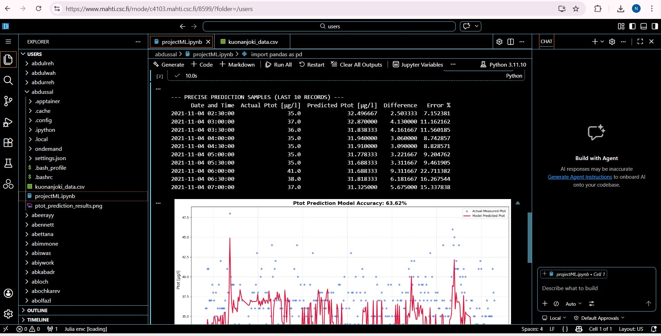
Figure 1: The model running on CSC Mahti (mahti.csc.fi). Execution time of 10.0 seconds is visible at the top of the cell.

4.2 Sample Predictions
The table below shows some predictions from the test set on the morning of November 4th, 2021.

Date & Time | Actual Ptot [µg/l] | Predicted Ptot [µg/l] | Error %
2021-11-04 02:30 | 35.0 | 32.50 | 7.15%
2021-11-04 03:00 | 37.0 | 32.87 | 11.16%
2021-11-04 03:30 | 36.0 | 31.84 | 11.56%
2021-11-04 04:00 | 35.0 | 31.94 | 8.74%
2021-11-04 05:00 | 35.0 | 31.78 | 9.20%
2021-11-04 06:00 | 41.0 | 31.69 | 22.71%
2021-11-04 07:00 | 37.0 | 31.33 | 15.34%

Most predictions are within 7 to 12 percent of the actual values. The biggest error is 22.7% at 06:00 when the actual Ptot jumped to 41.0 µg/l. These sudden spikes are harder for the model to predict because they happen quickly and do not always show up clearly in the sensor readings.

4.3 Visualization
Figure 2 shows the model output from the laptop run. The red line is the model prediction and the blue dots are the actual measured Ptot values for the last 300 test points.

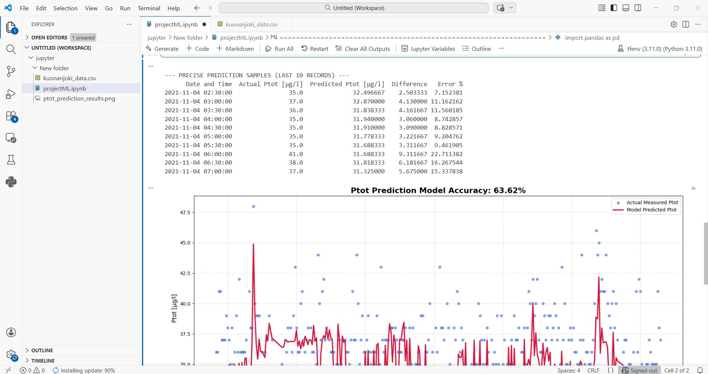
Figure 2: Predicted vs actual Ptot values for the last 300 test points. R² accuracy is 63.62%.

The model follows the general trend well but misses some of the bigger spikes. This is a known limitation when using sensor data alone to predict water quality.

5. Discussion
The model got an R² score of 63.62%. This means it can explain about two thirds of the changes in Ptot. For a first model using only sensor data, this is a decent result. But it is probably not accurate enough yet for real water quality monitoring.
One reason the accuracy is not higher is that phosphorus levels can be affected by things the sensors do not measure, like rain or soil runoff from nearby farmland. These kinds of events can cause sudden increases in Ptot that the model does not see coming. Adding weather data or information about land use nearby could help improve the model in the future.
Looking at the predictions in the table, the model works best when Ptot stays close to normal levels around 35 to 38 µg/l. The errors get bigger when there are sudden spikes. This is actually the most important case to get right in practice, so improving the model on spike events would be the most useful next step.
The results were identical on both the laptop and CSC Mahti, which shows the experiment is fully reproducible. The speed difference was noticeable for this small dataset. But if we wanted to train with more data, test many different model settings, or switch to a more complex model like a neural network, the supercomputer would make a much bigger difference. Those kinds of tasks would take a very long time on a laptop but could run quickly on CSC.

6. Conclusion
In this project we trained a Random Forest model to predict Ptot in the Kuonanjoki river using sensor data. The model got an R² score of 63.62% on both the laptop and CSC Mahti, which shows the results are the same in both environments.
The main difference between the two environments was speed. CSC Mahti finished training in 10 seconds while the laptop took around 45 seconds. For this project size the difference is not huge, but it would matter a lot if the project became bigger or more complex.
This task showed us that supercomputers are not only for very large projects. Even for a regular ML task, CSC is faster, more stable, and easier to scale up. If we wanted to extend this project with more data or a better model, CSC would be the right tool to use.

